Direct Deposit Authorization Form
Please print and complete ALL the information below.

Name or Agency: ____________________________________________________________

Tax-ID: ____________________________________________________________

Social Security: ____________________________________________________________

Address: ____________________________________________________________

City, State, Zip: ____________________________________________________________

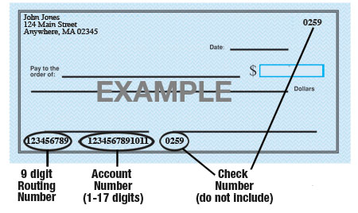

Name of Bank: ____________________________________________________________

Account #: ____________________________________________________________

9-Digit Routing #: ____________________________________________________________

Type of Account: Checking Savings

WOW Insurance Marketing is hereby authorized to directly deposit funds to the account listed above. This authorization will remain in effect until I modify or cancel it in writing.

Signature: ____________________________________________________________

Printed Name: ____________________________________________________________

Date: ___________________________

